**Azure Blueprints for Compliance**

**What are Azure Blueprints?**

Azure blueprints allows an engineer or architech to sketcy a project's design parameters and enables cloud architech and central information technlogy groups to define a repeatable set of azure resources that implements and adheres to an organizations standards, patterns and requirements. Blueprints are a declarative way to orchestrate the depoloyment of various resource templates and other artifacts like - Role Assignments, Policy Assignments, ARM Templtes, etc

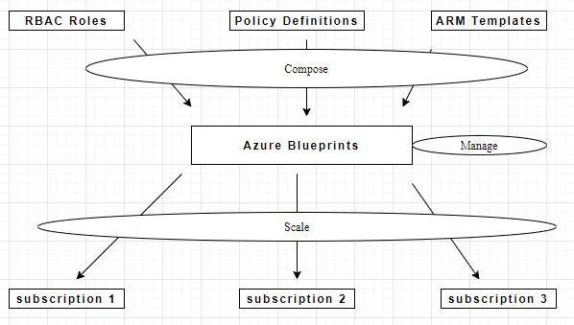

**How it can be used for compliance**

Microsoft has developed many base preconfigured blueprints for various compliances. One can simply create blueprint by and use one of Microsoft’s template and modify it to your needs.

How to:

1. In portal, go to the search bar and enter “blueprints”

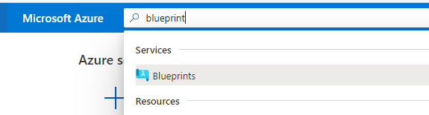

1. Click Create a policy. You will have an option to create one from scratch or copy one defined by Microsoft
2. Select Create and select one to copy
3. Give it a name and Location

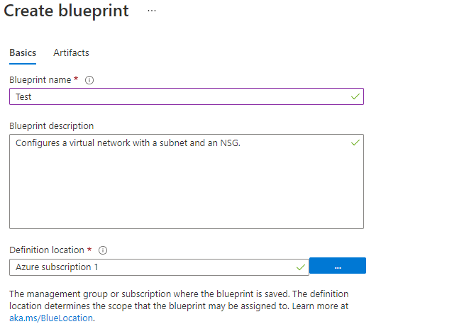

1. Modify the Artifacts if needed

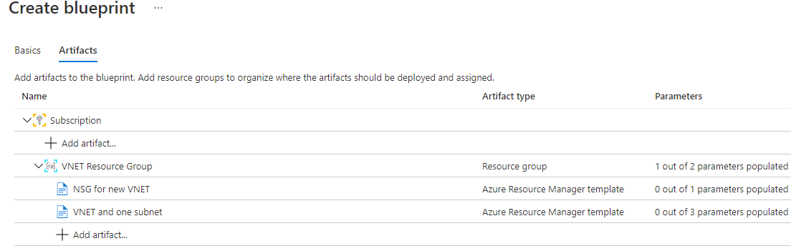

1. Save as Draft when Finished
2. Select the Subcription to apply the blue print to
3. Click apply blue print and it will deploy the subscription with settings from which ever compliance settings you need/choose